**Trauma in the Geriatric Population**

Objectives

On completion of the asynchronous course the student shall be able to:

Identify that Peoria County is just above the national average on percentage of geriatric population.

Realize that the vast majority of senior citizens stile live at home.

Understand that patients 65 years of age and older account for a disproportionality large number of prehospital calls.

Understand that the after cardiovascular calls trauma was the main reason for geriatric ambulance calls.

Relate how certain medications can alter the geriatric patient’s response and morbidity and mortality from trauma.

Explain how a geriatric patient’s ability to survive a traumatic insult may not as contingent on chronological age and it is on the patient’s overall health prior to the incident.

Explain how determining the cause of the fall is an important element of the care plan for each patient

Recognize that Beta-blockers, calcium channel blockers, and cardiac glycosides may lead to negative inotropic, dromotropic, and chronotropic effects

Understand that as high as many as 10% of the elderly patients presenting with trauma are on Coumadin.

Given a simulated geriatric patient with advanced dementia be able to perform a PAINAD scale on the patient.

**Introduction**

Multiple factors combine to make understanding of trauma in the geriatric patient important. In 2020 there were 59,792,501 men and women in the United States Age 65 and older, this composes 16.85% of the entire population. Of those 16,344,101 or 4.9% are in the even more vulnerable category of 75 – 84 years old. Peoria County is slightly above the national average with 17.68% or just over 32,000 people being 65 or older living in or around Peoria.

This segment of the population is growing. This increase in the numbers of the geriatric population is largely driven by the aging of the baby boomers (those born between 1946 and 1964), the first of whom turned 65 years old in 2011. As the baby boomers continue to age, the older population will make up an increasing share of the total. While we in EMS may think of geriatric patients as living in a nursing home, this is far from an accurate picture of our geriatric population. In 2020, 1.4 million people, or only 2.5 percent of the population aged 65 and over lived in nursing facilities/skilled nursing facilities. As age increased, the percentage of people living in nursing facilities increased, 0.9 percent of 65- to 74-year-olds, 2.7 percent of 75- to 84-year-olds, and 10.2 percent of people aged 85 and over lived in nursing facilities. As you can see only a very small percentage of even our oldest patient live in some type of nursing facility. Most still live at home.

The vast majority of people aged 65 and older still live at home, only 2.5% live in some type of nursing facility.

While the 65 years and older patients account for 16.85% of the United States population, nationwide they account for just over 40% of all ambulance calls. While the majority of those calls are for medical reasons, a significant number of those calls, in 2014 715,391 calls or 10.9%, were for trauma, the only other single category that had more EMS responses were cardiovascular emergencies5.

Caring for older patients at times can be problematic. Physical examination is difficult in the pre-hospital setting and may be especially difficult with older patients, who may have atypical physical presentations. Older patients often have multiple comorbidities that can exacerbate traumatic injuries. Many geriatric patients take medications that may compromise their body’s ability to compensate post traumatic injury. Anticoagulants increase bleeding, antihypertensive limit the body’s ability to constrict blood vessels in response to hypovolemia, and Beta Blockers will not allow the heart rate to increase in the presence of hypovolemic shock. The sensitive and frail physique of some older patients an important consideration as patient lifting, handling and transportation are important components of EMS care. Communication is commonly difficult in the pre-hospital environment and may be more challenging with older patients, who may exhibit declines in hearing and cognition, or who may become easily disoriented when taken out of familiar environments and exposed to excessive stimulation.

Anticoagulants increase bleeding, antihypertensive limit the body’s ability to constrict blood vessels in response to hypovolemia, and Beta Blockers will not allow the heart rate to increase in the presence of hypovolemic shock.

The term geriatric does have some ambiguity associated with it. Advanced Trauma Life Support (ATLS) teaching, recommends transport to a trauma center of any patient older than 55 years of age, the Eastern Association for the Surgery of Trauma (EAST) guidelines, recommend considering any patient older than 65 years as elderly2. All geriatric patients are not affected by trauma to the same degree. Morbidity and mortality from trauma increases after the age of 70 years3. A geriatric patient’s ability to survive a traumatic insult may not as contingent on chronological age and it is on the patient’s overall health prior to the incident. Often it is not as much a factor of the model year, but the mileage and maintenances. .

A geriatric patient’s ability to survive a traumatic insult may not as contingent on chronological age and it is on the patient’s overall health prior to the incident.

**Etiology**

Falls are the most common mechanism of injury in older adults, followed by motor vehicle collisions and burns. According to the United States Centers for Disease Control and Prevention (CDC), in 2014 alone, adults age 65 and older experienced 29 million falls, causing 7 million injuries.

Determining the cause of the fall is an important element of the care plan for each patient, as the fall may result from an isolated mechanical process or a systemic condition that puts the patient at risk for additional falls. When assessing these patients, the patient’s functional status before the fall, along with the location and circumstances of the fall, should be considered. Even if a reliable mechanical cause of the fall can be established, a complete medical evaluation should be considered to evaluate for a pathological condition that caused the fall. Occult anemia, electrolyte abnormalities, and disorders of glucose metabolism should be considered.

Determining the cause of the fall is an important element of the care plan for each patient

Attention should also be paid to the possibility of cardiovascular causes of the fall, including orthostatic hypotension, dysrhythmia, and myocardial infarction. Other pathological states that can lead to falls include infection from urinary, pulmonary, or soft tissue sources. Neurologic disorders, including primary or secondary seizures, should be on the differential diagnosis. The role of polypharmacy and potential disruptions to normal physiologic function cannot be understated.

Trauma is the fifth leading cause of death in older adults and accounts for up to 25% of all trauma admissions nationally. Those aged 65 and older are more prone to traumatic injuries due to factors such as decreased bone density, slower reflexes, and a higher prevalence of comorbidities. Special considerations include polypharmacy, decreased functional reserve, and increased morbidity and mortality compared to younger adults. Mortality from traumatic injuries increases after age 70 when adjusting for injury severity score. Prehospital trauma triage criteria specific to older adults improve the identification of those needing trauma center care.

Falls are the most common etiology of traumatic injury.[Research has revealed that elderly patients older than 65 years old have about a 27% chance of fall in any given year. Most of the falls in the geriatric population tend to be ground-level falls, which would otherwise be benign in younger patients.

Elderly patients older than 65 years old have about a 27% chance of fall in any given year.

In similar mechanism of injury geriatric patients present with significantly more severe injuries, they remain in the hospital longer, require greater use of resources after discharge, and die at 3 times the rate of the younger population. Not only are geriatric patient more likely to fracture bones in a fall than younger patients, their outcome is much more likely to be fatal than in younger populations. The most common fractures in geriatric patients were of the rib, distal radius, pelvic ring, facial bones, proximal humerus, clavicle, ankle, and sacrum1. Injuries associated with the highest mortality rates include but are not limited to.

Proximal femur 25% mortality

Pelvic ring 25% mortality

Clavicle 24% mortality

Distal humerus 24% mortality

**Pathophysiology**

Aging brings about a host of fascinating physiological changes that reflect the resilience and adaptability of the human body. While certain functions may slow down, the body often compensates remarkably by developing greater efficiency in some processes and prioritizing essential functions. The many anatomic and physiologic changes in multisystem organ function associated with normal aging must be considered when caring for an older patient with a traumatic injury.

**Nutritional**

Older patients may present with various degrees of malnutrition. Malnutrition may be due to a lack of protein or total caloric intake. Various mineral and supplement deficiencies should also be considered. These nutritional shortcomings may be multifactorial, such as living on a fixed income, inability to obtain healthy food from stores, reduced appetite, poor taste, and inability to prepare meals or feed oneself. Nutritional deficiencies have significant effects, including decreased healing capability and reduced immune responses. Malnourished older patients with traumatic injuries are at a higher risk for morbidity and mortality.

**Integument/Musculoskeletal**

Older individuals have decreased lean body mass, loss of tissue elasticity, thinning of the skin, and an overall increase in total body fat. Skin thinning makes thermoregulation more difficult, and older individuals are much more susceptible to hypothermia, even in warm weather conditions. Skin becomes much less resistant to shearing forces as the overall elastic content decreases, increasing susceptibility to skin tears and avulsions even with minor energy transfers. An increase in total body fat results in a larger distribution volume; this needs to be considered when administering medication.

Bone density is often decreased by osteopenia and osteoporosis. Loss of bone density coupled with loss of lean muscle mass leads to loss of strength and locomotion, balance issues, and decreased ability to produce heat through shivering. Furthermore, loss of bone density leads to a higher risk of fracture with lower energy injury mechanisms.

**Neurologic**

Neurohumoral responses in older patients are often blunted, which leads to a slower and less vigorous response to stimuli. Older patients frequently have neurocognitive decline and may present with reduced sensation to nervous stimuli. Comorbidities, such as diabetes, can lead to peripheral neuropathy, a loss of sensation and proprioception, and increased susceptibility to pressure wounds and injuries from falls.

The brain parenchyma also atrophies and loses volume with age, leading to stretching of the bridging dural veins. When an older individual has a sudden inertial change, such as a fall with a head strike, these veins are at high risk for rupture, leading to subdural hemorrhage. Compounded with the fact that the brain shrinks in size, but the cranial cavity maintains a fixed volume, clinical changes associated with intracranial hypertension often present in a delayed fashion as it takes more blood volume to lead to brain compression and shift. This process is somewhat protective because older patients may not immediately have significant clinical deterioration or need emergent surgical intervention to evacuate the hemorrhage.

Because normal parenchymal atrophy occurs with aging, there may also be systemic changes, such as a decreased ability to autoregulate blood flow. Older patients are more likely to take multiple medications, and adverse effects of these medications could lead to drowsiness, loss of energy, oversedation, and loss of balance and memory. Prescribed medications can increase the risk of falls, motor vehicle collisions, and other mechanisms of injury.

**Cardiovascular**

Connective tissue stiffening comes with age, and this change notably affects arteries, veins, and the myocardium. The aging heart becomes stiffer and less compliant, losing the ability to increase contraction and cardiac output when experiencing a more significant preload. With time, the cardiac conduction system becomes more fibrotic, and the myocardium becomes less responsive to neurohumoral effects; this all leads to a decreased ability to preserve cardiac output, defined as the product of heart rate and stroke volume.

For relatively mild hypovolemia, whether due to poor intake with associated dehydration or volume contraction or related to injury with hemorrhage, the resultant drop in preload significantly affects the overall cardiac output in older adults. When the vascular system is desensitized to neurohumoral effects, there is less ability for the systemic vascular resistance to increase the peripheral blood pressure or for the venous system to contract, leading to a decreased ability to increase preload.

Polypharmacy can have several effects on the cardiovascular system in this demographic. Beta-blockers, calcium channel blockers, and cardiac glycosides may lead to negative inotropic, dromotropic, and chronotropic effects. Under normal circumstances, this is the desired effect of the medication; with an acute insult, these medications prevent the injured host from mounting a normal physiologic response to compensate and maintain homeostasis.

Beta-blockers, calcium channel blockers, and cardiac glycosides may lead to negative inotropic, dromotropic, and chronotropic effects.

Shock, defined as global tissue hypoperfusion, is often clinically defined as a systolic blood pressure less than 90 mm Hg. This definition is often incomplete for many patients, especially those older than 65. Current literature supports a systolic blood pressure of 110 mm Hg as a better benchmark for identifying occult shock.

**Pulmonary**

Overall, pulmonary function deteriorates in older adults. With age, the elastic recoil of lung parenchyma decreases as the number of crosslinking elastic fibers decreases. Older adults typically have less functional residual and vital lung capacities, with the total lung capacity either staying the same or mildly decreasing. Formal pulmonary function testing often reveals that this population has lower forced expiratory volumes over 1 second and forced vital capacity. Therefore, the respiratory reserve is limited, and the ability to adapt compensatory physiologic processes to hypoxia, hypercarbia, and metabolic abnormalities, such as acidosis, is blunted. Clinically, even MOI that would be insignificant to a younger patient, to the older patient may manifest in respiratory failure, and often, the clinical signs or symptoms may be subtle.

Additionally, as older adults lose lean muscle mass, their ability to recruit secondary respiratory muscles is decreased. Along with loss of tissue elasticity and greater total body fat deposition, there is a decrease in chest wall compliance. Age-related osteoporosis may also alter thoracic geometry, reducing diaphragmatic curvature and decreasing maximal transdiaphragmatic pressure.

Suboptimal nutritional intake also contributes as older individuals often have inanition contributing to respiratory failure as they tire from attempting to compensate for metabolic disturbances. Atelectasis is very common in this demographic, and atelectasis can lead to underlying ventilation-to-perfusion mismatch with a resultant increase in pulmonary shunting.

The ability to maintain proper pulmonary hygiene also decreases with age, and there is often chronic airway colonization with microbes. The normal pseudostratified ciliated epithelium and goblet cells, which are responsible for the mucociliary escalator, fail to remove microbes and particulate matter from the lower airways, and the older adult’s cough is often weak due to loss of muscle mass, which prevents effective pulmonary hygiene.

Chronic aspiration due to dysphagia is often seen in this patient population, which significantly affects the underlying pulmonary function. Chronic aspiration should be considered in all older adults with a history of obesity, sedating medications, gastroparesis associated with diabetes, or gastroesophageal reflux to prevent worsening aspiration and respiratory failure if laid supine. Strict aspiration precautions and, if indicated, gastric tube decompression should be considered to prevent this possibly catastrophic event.

**Gastrointestinal**

Poor dentition leads older patients to become edentulous (toothless), necessitating prosthetic dentures. Loss of the ability to chew foods can lead to poor nutritional intake. Salivary glands also atrophy, leading to decreased saliva production, which impairs the lubrication of the food bolus, making the process of deglutition more challenging. Transfer of the food bolus from the oropharynx to the esophagus is also impaired and can lead to aspiration as prior protective aerodigestive reflexes are often blunted or absent.

Multiple medications affect the gastric lining and acidic milieu. These alterations can worsen the protective mechanisms of the gastric wall and lead to gastritis and other forms of peptic ulcer disease. The pharmaceutical alkalization of gastric acid can lead to microbial overgrowth. In this case, if aspiration does occur, it can lead to a higher rate of pulmonary infection.

Gastric and intestinal wall integrity is also affected by age, leading to poor absorption of both micro- and macronutrients and malnutrition. Additionally, overall motility is slowed as the tissues become less responsive to neurohumoral and endocrine stimuli. Older adults have been shown to have an increased number of uncoordinated esophageal contractions and decreased gastric emptying. This can lead to a higher risk of reflux in this age group.

Over time, the liver loses its overall parenchymal mass, and blood flow to the liver decreases, resulting in a worsening ability to filter the bloodstream. The liver’s intrinsic ability to make proteins, such as albumin, is also diminished, which can lead to a decrease in oncotic pressure and worsening of the third-spacing of fluids. Also, free drug concentrations can increase in the face of hypoalbuminemia, leading to unwanted toxicities and adverse effects.

Decreased hepatic production of thrombopoietin can lead to thrombocytopenia due to decreased stimulation of the megakaryocytes in the bone marrow. Vitamin K-dependent clotting factors are also diminished due to poor oral vitamin K intake and loss of hepatic synthetic function. Both factors can lead to a higher risk of coagulopathy in the geriatric trauma population.

**Hematologic**

Bone marrow mass may also decrease with age. Fat replaces marrow, and hematopoietic reserves decline. The marrow itself also becomes less sensitive to stimulatory hormones. The functionality of the red cells, platelets, and leukocytes all develop qualitative defects even though, quantitatively, they may be normal.

Anemia is prevalent in older adults, and a differential should be obtained. The mean corpuscular volume helps delineate the cause of the anemia further. Macrocytic anemia is usually caused by folate or B12 deficiencies, most commonly caused by poor nutritional intake or absorption issues, both seen in older adults. Microcytic anemia is often due to iron deficiency or other dietary inadequacies, but it can be secondary to other causes, such as occult blood loss. Anemias should be evaluated and corrected to help preserve or increase oxygen-carrying capacity.

**Endocrine**

Older adults are at higher risk for impaired glucose tolerance or diabetes due to a relative decrease in insulin secretion by β-cells and peripheral insulin resistance. Many older patients are on systemic steroids, which may lead to hyperglycemia, immunosuppression, and decreased wound healing rates. Furthermore, chronic glucocorticoid therapy is associated with hypothalamic-pituitary-adrenal axis suppression, which puts patients at risk for adrenal suppression, requiring stress dosing at times of surgery, traumatic injury, or during critical illness. Also, many older adults are on thyroid hormone replacement therapy, and critically ill patients may become hypothyroid or euthyroid-sick. The astute clinician should keep these common endocrinopathies in mind when caring for an older adult with traumatic injuries.

**Assessment**

The history and physical examination of an older adult with a traumatic injury require a comprehensive and meticulous approach, recognizing the complexities of aging. The history should include details of the trauma event, preexisting medical conditions, medications, and baseline functional status, including cognitive and sensory abilities. Particular attention should be paid to medications that affect coagulation, cardiovascular stability, and cognitive function, as these can significantly impact the patient’s response to trauma. All resources available for collateral information should be utilized.

During the physical examination, EMT/paramedics must carefully assess for subtle signs of injury, which may be masked by age-related changes such as reduced pain sensation and altered mental status. A thorough physical examination entails vital signs, neurological status, and a head-to-toe assessment to identify potential injuries. Often, vital signs appear normal until the patient deteriorates rapidly, as physiologic reserve is poor in this population. Blood pressure and pulse may mislead and be altered by polypharmacy. Bruising, skin tears, and hematomas should be evaluated for underlying injury. Comorbid conditions must be taken into consideration. Given the higher risk of complications, even seemingly minor trauma in older adults warrants a detailed and cautious evaluation to ensure optimal care and outcomes.

In geriatric patients vital signs may appear normal until the patient deteriorates rapidly, as physiologic reserve is poor in this population.

**Scenarios**

Scenario 1

You are dispatched for an elderly woman who has fallen and is unable to get up. On arrival you find a72-year-old white female, approximately 90 kg, laying on the carpeted floor, she is ACOX4, and tells you 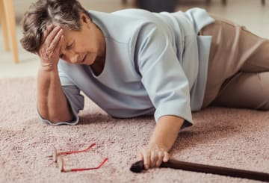that she has fallen and her hip hurts very badly. By the tone of her voice you can tell that she is in pain.

First things first, we should always perform a primary assessment, assuring that there are no major bleeds, assessing her airway while at the same time considering the need for spinal precautions, assure adequate breathing and circulation. If there are any areas of concern in the primary survey they must be addressed and the patient transported as quickly as possible. If it is an isolated hip fracture, we have time and should address several issues on scene prior to transporting.

**Discussion**

Once it has been established from the primary survey that there is no immediate threat to life, the paramedic (or other attending ambulance staff) will complete a comprehensive secondary survey whilst still being mindful of the need for this patient to get to definitive care in a timely manner. This process includes acquiring a patient history as well as undertaking a ‘head to toe’ physical assessment and documenting a full set of vital signs.

As part of the secondary survey, gaining a patient history as soon as possible after the fall is likely to give the most accurate account. History taking should be structured and include details of the fall and events leading up to it, the past medical history, allergies and medications and a social history .Global characteristics of the patient and their environment are noted, including general appearance, living arrangements and level of independence.

Patients with a fall and a ‘long lie’, which is considered anything in excess of one hour, are at risk of hypothermia, compromised skin integrity due to unrelieved pressure, rhabdomyolysis and aspiration pneumonia.

Early pain assessment and management is a key role for pre-hospital clinicians. Classically in patients with a hip fracture, there is pain on movement of the leg, in the groin and/or thigh, with pain referred to the knee

Early establishment of the patient’s vital signs is recommended to identify possible preexisting illness, monitor the patient’s progress and recognize any deterioration in their clinical status. Basic observations should include blood glucose testing to rule out hypoglycaemia. The assessment of the limb should include inspection and palpation, comparing it to the uninjured side, examining for irregularities/deformities, swelling or bruising. Classically, with a hip fracture there is shortening and external rotation of the leg. Undisplaced hip fractures may have no signs, but patients may complain of pain on internal rotation and will be unable to straight-leg raise the affected limb. Patients may be able to get up but then are unable to weight bear due to pain. In older people presenting with these signs and symptoms, ambulance crews should have a low threshold for transferring the patient to definitive care.

If the emergency call relates to a fall where no clear extrinsic reason can be identified, then a 12-lead ECG should be performed, and a brief neurological assessment such as FAST (Face/Arm/Speech Test) should be undertaken to exclude stroke/TIA

Pain management should include non-pharmacological options such as splinting, immobilization and positioning in addition to the use of pharmacological agents, always with continual assessment of the level of the patient’s pain.

Consideration needs to be given to both static pain (when the patient is at rest) and dynamic pain (when the patient is moving or being moved). Adequate analgesia should be given prior to moving the patient when transferring them from the scene of the injury to the ambulance and during transportation to hospital. Pain rating scales may be used to assess the efficacy of any drugs or techniques used to control and reduce pain. Whatever scale is used, it is essential to assess pain levels both before and after intervention to ensure effective management. Older patients with frailty are often dehydrated and should be given intravenous fluids. Caution needs to be exercised in patients with a history of heart failure.

EMTs and paramedics must consider the best method of transferring the patient with a hip fracture into the ambulance and transporting them. A stair chair is not appropriate with the risk of further damage at the site of injury and is likely to be extremely painful for the patient. An scoop stretcher is a good option, if a scoop stretcher is not available a backboard can be used to move the patient from the ground to the cot.

Pre-hospital clinicians have an important role in the management of patients with hip fracture. They are well placed to get a clear account of the patient’s fall, comorbidities and circumstances and handover of this information to the hospital team can save time and repetition. Early appropriate management of pain and hydration can also influence peri-operative complications. It is important that pre-hospital staff and hospital staff work and learn together, to continually improve patient care.

**Scenario 2**

You are called to an assisted living complex for a man who has fallen and is unresponsive, enroute you are advised that the patient is now conscious and talking. On arrival on scene you are escorted to an apartment where you find a 72 year old male laying on the floor with several older women around him One of the ladies is holding a yapping Chiwinnie, and several employees of the assisted living. The gentleman notes your arrival and quickly says, “I am so glad you are here, would you please help me up, they keep telling me that I have to stay on the ground until you get here”. You quickly do a primary assessment and clear his c-spine. The gentleman tells you that they were playing bridge and he got up to get a drink and tripped over the Chiwinnie, falling and striking his head on the carpeted floor. You ask if he lost consciousness, he answers “Yeah I was out for a bit, when I came to these lovely ladies were all hovering over top of me”. All the women agree with the story, one adds that she is the one that called 911. You patient is a 72-year-old male, he appears in very good shape for his age and relates that his only history is A-fib. He takes a multivitamin every day, one 81 mg Aspirin, Cardizem, 60 mg three times a day, and 20 mg of Xarelto daily. His vitals are unremarkable and his 12-lead shows NSR. His blood sugar is 89 mg/dl. His neuro exam is normal, negative FAST and GCS of 15.

Your patient is adamant that he does not want to be transported to the hospital noting that if he develops any problems he will have someone drive him to a prompt care or make an appointment with his primary care physician.

Conclusion A

You are equally adamant that your patient should be transported to the ED as soon as possible. You carefully explain to your patient the risks involved in signing the refusal. You educate your patient on the risk of an epidural bleed and the limitations of EMS, i.e. the ability to do a CT of his head. After your repeated offers to transport, and the encouragement of the lady friends, you patient finally agrees and he is transported to OSF St. Francis where he is diagnosed with an epidural bleed and under goes surgery later that day. After a few days in neuro ICU and several days in a step-down unit he is sent home with no neuro deficits.

Conclusion B

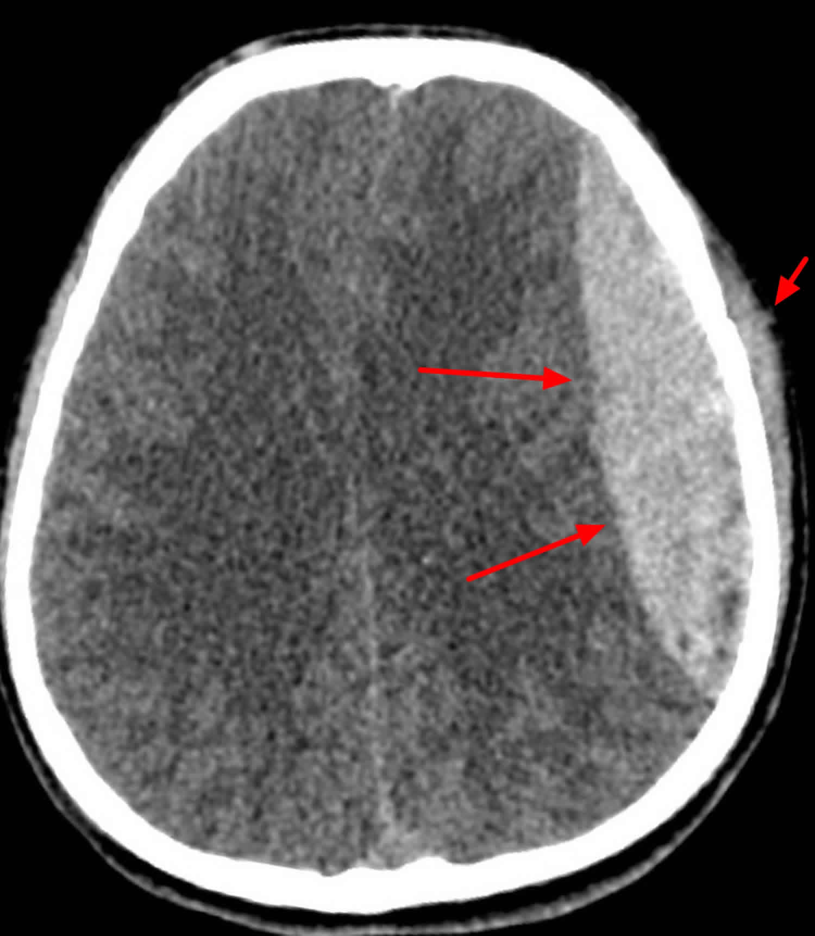You accept the refusal and leave the patient in care of his friends. You are told several days later that there was another call at the same residence for a man not breathing. When the crew arrived on scene they found him in bed, apneic, no pulse and with rigor mortis. His friends noted that he developed a headache later the day of the fall and went to bed. When no one had heard from him the next day the building manager entered his apartment to find him lying in bed and called 911.

**Discussion**

Head trauma in the elderly represents a particularly challenging subset of cases in patients with trauma.  Elderly patients tend to have a higher number of chronic medical conditions, which increases the risk of death in traumatic injuries. When compared to younger patients, elderly patients with traumatic head injuries were much more likely to die or require long term care.

While age 65 is commonly used as a default; however, evidence supports that a patient's preexisting conditions and comorbidities may be a better predictor of long term complications secondary to trauma.  These comorbidities in older patients make them more susceptible to falls, such as in unilateral weakness secondary to stroke.  Also, elderly patients commonly take more medications, which can precipitate falls, cause confusion, or worsen bleeding.  For example, aspirin or even more potent forms of anticoagulation, such as coumadin, can drastically worsen traumatic intracranial bleeds.  These chronic conditions compounded by the effects of polypharmacy cause elderly patients to have less capacity to compensate for traumatic injuries.

A subset of the elderly population that requires special consideration are the patients on anticoagulation.  A variety of medical conditions such as atrial fibrillation, pulmonary embolism, or deep vein thrombosis require the use of anticoagulation medications. These conditions become increasingly common as the population ages.  In fact, as high as 10% of the elderly patients presenting with trauma are on Coumadin. Coumadin is the most commonly used anticoagulant, but the use of newer direct oral anticoagulant medications such as dabigatran is rapidly increasing.  All of these medications increase the amount and rate of bleeding, which would increase the chance of long term disabilities and the possibility of death.

As high as many as 10% of the elderly patients presenting with trauma are on Coumadin.

**Scenario 3**

You are called to a 2-car T-bone, MVC. You are the second in rig and arrive to two mid-size cars have had a T-bone collision in a residential intersection. The scene is save, traffic is controlled and you are directed to a car that was struck on the passenger side, it had moderate damage with very little intrusion into the passenger compartment. Your patient is still in the car, seated behind in the driver’s seat, an officer on scene advises you that she had run the stop sign and was struck broadside by the other vehicle. You approach the care from the undamaged passenger side and 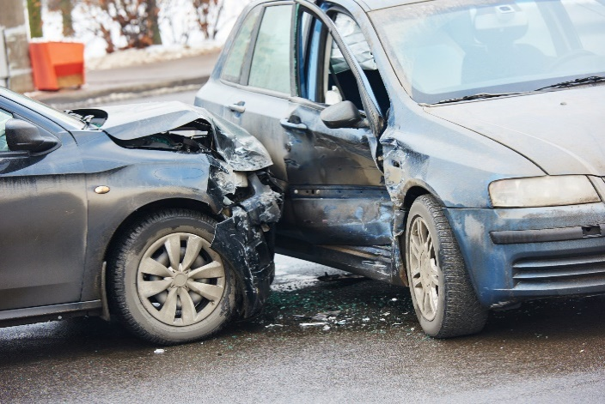your immediate impression is how in the world was this lady even able to see over the dash. Behind the steering wheel is a woman who appears to be in her 80s, very short in stature and you immediately notice she is hunched over. You start talking to her to find her level of consciousness and she replies and answers all questions appropriately, but she does seem to worry more about the damage to her car and that her grandson will be upset with her for getting in an accident again. She is complaining of neck pain and pelvic pain. Her vitals are well within normal ranges, Blood pressure is 128/82, pulse of 62 and RR of 20. You have no idea how you are ever going to get a C-collar on her let alone put her on a backboard because of the curvature of her spine. She is a very poor historian and cannot tell you much of her medical history, medication list, or allergies. She tells you repeatedly that you will have to ask her grandson.

**Discussion**

A recent study showed a linear association between different patterns and intensity of injury and aging. As age increased, low-energy traumas complicated with the use of antiplatelets and anticoagulants were more prevalent.

Motor vehicle collisions account for up to one-quarter of patients with geriatric trauma, with 26.8% in the 66-75 years group and 14.4% in patients older than 75 years. Elderly patients are more likely to present severe injuries caused by low speed vehicles and have a doubled mortality rate than younger counterparts

Elderly patients are at a significantly increased risk of high cervical spinal cord injuries (C1-C2) as a result of degenerative changes and stiffening of the lower cervical spine. In this scenario, early spinal evaluation and appropriate spine immobilization are of paramount importance to avoid secondary devastating injuries.

Pelvic fractures in the elderly have a higher incidence of complications and mortality than in the younger population. Specifically, the pattern of injury is different with a higher incidence of lateral compression fractures,

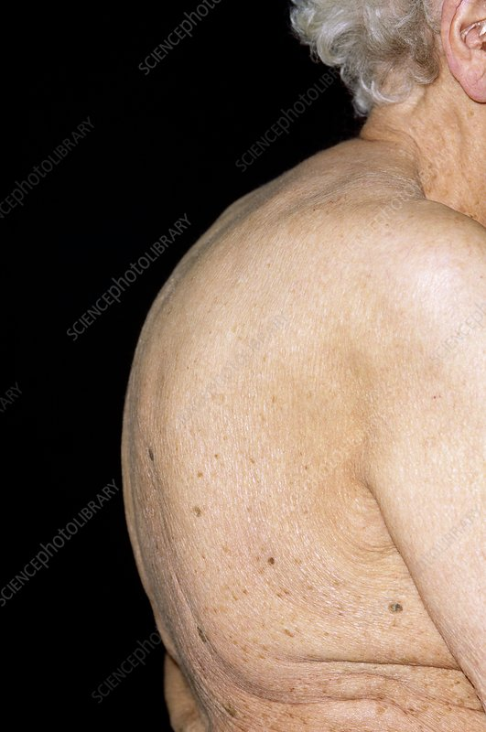In elderly patients, with kyphosis the “neutral position” adopted for cervical spine immobilization may not be appropriate. Each patient must be assessed on an individual basis including the fracture morphology, to minimize the risk of fracture displacement and worsened neurological deficit. The prehospital clinician may simply have to be creative when accommodating for physical deformities, use whatever materials are on hand (e.g., pillows, blankets, splints) to help make your patient more comfortable. Never force the patient’s head, neck, spine or extremities into a “neutral” position. Pre-existing conditions, **,**can make this positioning impossible, and attempting it can lead to further injury.

Consensus exists that elderly trauma patients are usually under-triaged to trauma centers. Different underlying causes have been described, such as low-energy mechanisms of injury, unconscious age bias, unreliability of vital signs, and the use of medications that can blunt the physiologic response to injury.

In summary, elderly trauma patients present specific characteristics that imply increased morbidity and mortality. Appropriate triage, recognition of hypotension and hypoperfusion, despite normal or near normal vital signs on presentation, and early intensive monitoring and resuscitation improve survival.

**The Pain Assessment in Advanced Dementia Scale (PAINAD)**

Geriatric patients with advanced dementia may not be able to use a numeric pain scale or Wong-Baker Faces to tell pre-hospital providers that they are experiencing pain and the severity of that pain. Clinicians can still access their pain. The Pain Assessment in Advanced Dementia (PAINAD) Scale gives us the abilty to access pain in this specific subset of geriatric patients. PAINAD was developed in 2003 by Victoria Warden, Ann C. Hurley, and Ladislav Volicer to provide a clinically relevant and easy to use pain assessment tool for individuals with advanced dementia. The tool covers five behavioral categories: breathing, negative vocalization, facial expression, body language, and consolability. Each item is scored on a 3-point scale (0-2) for severity, resulting in a scoring range of 0-10. Studies have been conducted on PAINAD since it was developed, that shows validity with other pain scales and self-report, with similar findings in self-reports of both pain and discomfort, using a visual analog scale. Validity has also been shown, with a significant reduction in score following analgesic administration,

PAINAD Scale is a comprehensive tool that assesses and manages pain in older adults with dementia and delirium in a pre-hospital setting. It focuses on observable signs of pain rather than patient self-report, making it particularly useful for individuals who cannot communicate their discomfort. PAINAD Scale is part of a proactive approach to improve overall well-being and reduce the likelihood of undetected and untreated pain in dementia patients. Incorporating the PAINAD Scale into routine patient assessments enhances the effectiveness of pain management plans and improves pain treatment outcomes.

|  |  |  |  |  |
| --- | --- | --- | --- | --- |
| Items | 0 | 1 | 2 | Score |
| **Breathing independent of vocalization** | Normal | Occasional labored breathing, short period of hyperventilation | Noisy labored breathing, long period of hyperventilation, Cheyne-Stokes respirations |  |
| **Negative vocalization** | None | Occasional moans or groans, low-level speech with a negative or disapproving quality | Repeated troubled calling out, loud moaning or groaning, crying |  |
| **Facial expression** | Smiling or inexpressive | Sad, frightened, frown | Facial grimacing |  |
| **Body Language** | Relaxed | Tense, distressed pacing, fidgeting | Rigid, fists clenched, knees pulled up, pulling or pushing away, striking out |  |
| **Consolability** | No need to console | Distracted or reassured by voice or touch | Unable to console, distract, or reassure |  |
| **Total** | | | |  |

**Breathing**

1. Normal breathing is characterized by effortless, quiet, rhythmic (smooth) respirations.

2. Occasional labored breathing is characterized by episodic bursts of harsh, difficult or wearing respirations.

3. Short period of hyperventilation is characterized by intervals of rapid, deep breaths lasting a short period of time.

4. Noisy labored breathing is characterized by negative sounding respirations on inspiration or expiration. They may be loud, gurgling, or wheezing. They appear strenuous or wearing.

5. Long period of hyperventilation is characterized by an excessive rate and depth of respirations lasting a considerable time.

6. Cheyne-Stokes respirations are characterized by rhythmic waxing and waning of breathing from very deep to shallow respirations with periods of apnea (cessation of breathing).

**Negative vocalization**

1. None is characterized by speech or vocalization that has a neutral or pleasant quality.

2. Occasional moan or groan is characterized by mournful or murmuring sounds, wails or laments. Groaning is characterized by louder than usual inarticulate involuntary sounds, often abruptly beginning and ending.

3. Low level speech with a negative or disapproving quality is characterized by muttering, mumbling, whining, grumbling, or swearing in a low volume with a complaining, sarcastic or caustic tone.

4. Repeated troubled calling out is characterized by phrases or words being used over and over in a tone that suggests anxiety, uneasiness, or distress.

5. Loud moaning or groaning is characterized by mournful or murmuring sounds, wails or laments much louder than usual volume. Loud groaning is characterized by louder than usual inarticulate involuntary sounds, often abruptly beginning and ending4.

6. Crying is characterized by an utterance of emotion accompanied by tears. There may be sobbing or quiet weeping.

Facial expression

1. Smiling is characterized by upturned corners of the mouth, brightening of the eyes and a look of pleasure or contentment. Inexpressive refers to a neutral, at ease, relaxed, or blank look.

2. Sad is characterized by an unhappy, lonesome, sorrowful, or dejected look. There may be tears in the eyes.

3. Frightened is characterized by a look of fear, alarm or heightened anxiety. Eyes appear wide open.

4. Frown is characterized by a downward turn of the corners of the mouth. Increased facial wrinkling in the forehead and around the mouth may appear.

5. Facial grimacing is characterized by a distorted, distressed look. The brow is more wrinkled as is the area around the mouth. Eyes may be squeezed shut

**Body language**

1. Relaxed is characterized by a calm, restful, mellow appearance. The person seems to be taking it easy.

2. Tense is characterized by a strained, apprehensive or worried appearance. The jaw may be clenched (exclude any contractures).

3. Distressed pacing is characterized by activity that seems unsettled. There may be a fearful, worried, or disturbed element present. The rate may be faster or slower.

4. Fidgeting is characterized by restless movement. Squirming about or wiggling in the chair may occur. The person might be hitching a chair across the room. Repetitive touching, tugging or rubbing body parts can also be observed.

5. Rigid is characterized by stiffening of the body. The arms and/or legs are tight and inflexible. The trunk may appear straight and unyielding (exclude any contractures).

6. Fists clenched is characterized by tightly closed hands. They may be opened and closed repeatedly or held tightly shut.

7. Knees pulled up is characterized by flexing the legs and drawing the knees up toward the chest. An overall troubled appearance (exclude any contractures).

8. Pulling or pushing away is characterized by restiveness upon approach or to care. The person is trying to escape by yanking or wrenching him or herself free or shoving you away.

9. Striking out is characterized by hitting, kicking, grabbing, punching, biting, or other form of personal assault.

Consolability

1. No need to console is characterized by a sense of wellbeing. The person appears content.

2. Distracted or reassured by voice or touch is characterized by a disruption in the behavior when the person is

spoken to or touched. The behavior stops during the period of interaction with no indication that the person is at all distressed.

3. Unable to console, distract or reassure is characterized by the inability to sooth the person or stop a behavior with words or actions. No amount of comforting, verbal or physical, will alleviate the behavior.

Conclusion

Each year thousands of elderly citizens suffer traumatic injuries. EMS providers have the opportunity to positively impact their outcome with rapid, thorough assessments of injuries, as well as appropriate treatment and transport determinations. This may necessitate a combination of an in-depth medical history, physical exam and consultation with medical control.

References

1. Keller, Julie M. MD; Sciadini, Marcus F. MD; Sinclair, Elizabeth MA; O'Toole, Robert V. MD. Geriatric Trauma: Demographics, Injuries, and Mortality. Journal of Orthopaedic Trauma 26(9):p e161-e165, September 2012. | DOI: 10.1097/BOT.0b013e3182324460
2. The Eastern Association for the Surgery of Trauma. Geriatric trauma (update). Available at: <http://www.east.org/resources/treatment-guidelines/geriatric-trauma-(update)>
3. Caterino, J.M. ∙ Valasek, T. ∙ Werman, H.A., Identification of an age cutoff for increased mortality in patients with elderly trauma, Am J Emerg Med. 2010; 28:151-158
4. Warden V, Hurley AC, Volicer L. Development and psychometric evaluation of the pain assessment in advanced dementia (PAINAD) scale. J Am Med Dir Assoc. 2003;4:9-15.
5. Duong HV, Herrera LN, Moore JX, Donnelly J, Jacobson KE, Carlson JN, Mann NC, Wang HE. National Characteristics of Emergency Medical Services Responses for Older Adults in the United States. Prehosp Emerg Care. 2018 Jan-Feb;22(1):7-14. doi: 10.1080/10903127.2017.1347223. Epub 2017 Sep 1. PMID: 28862480; PMCID: PMC5760278.